**Level of satisfaction regarding online education by age**

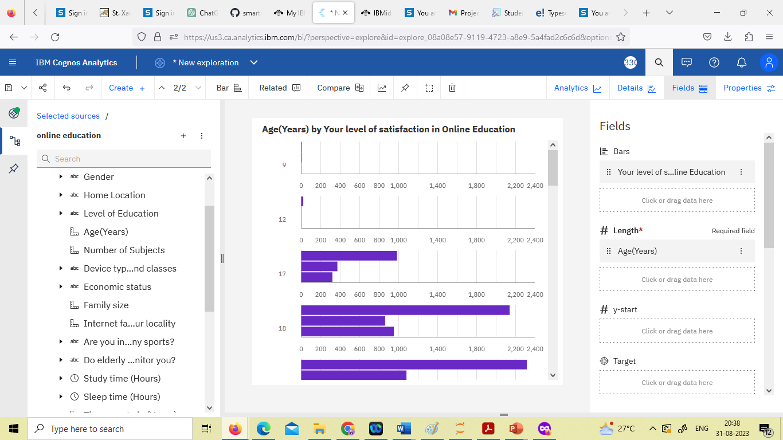

**Time spent on social media by Device types used to attend classes.**

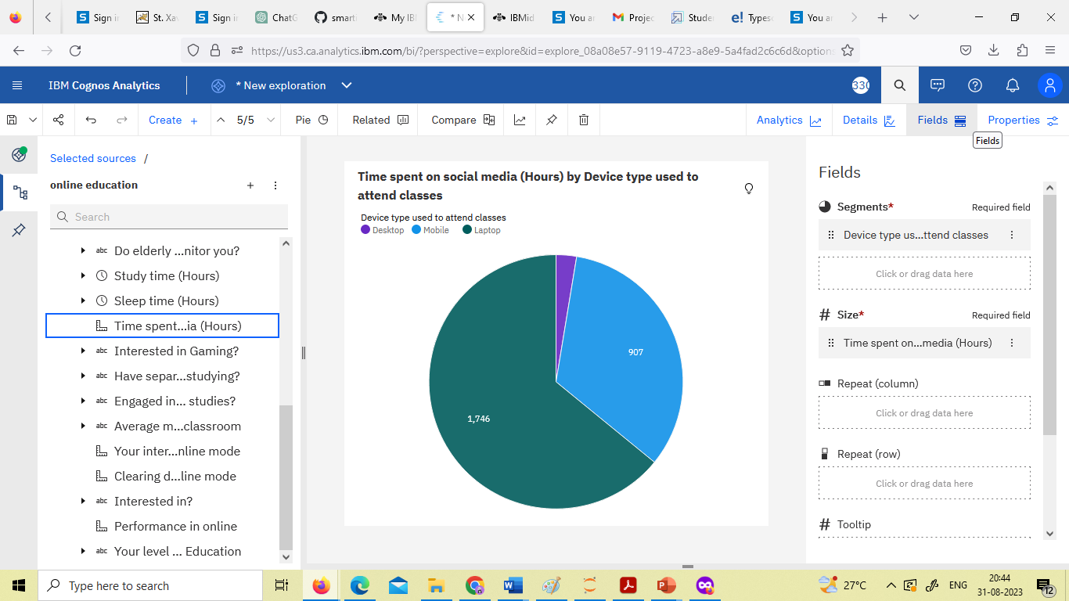

**Correlation between economic status, home & student online performance**

